**Name: SHAMJAD MAZOOD NAZER**

**Roll No: 36**

**Batch: B**

**Date: 28-03-2022**

**NETWORKING & SYSTEM ADMINISTRATION LAB**

**Experiment No.: 2**

**Aim**

Familiarization of Linux Commands.

**Procedure**

1. **cat**
   1. **cat -n ‘filename’:** Prints the contents of the mentioned file along with the numbers to the contents according the no. of lines.

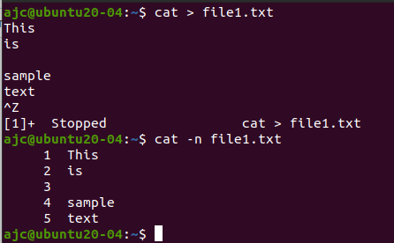

* 1. **cat -b ‘filename’:** This command prints the counted no. of the lines along with the numbers avoiding the black space new lines with the count.

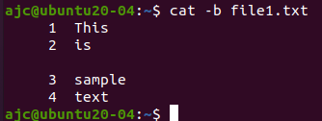

1. **touch ‘new filename’:** Creates a new file according to the mentioned name.



1. **echo ‘contents’:** Prints the contents mentioned along with the command to the terminal.



* 1. **echo ‘contents’ >> ‘filename’:** This command also adds/appends the mentioned contents to the mentioned file just like the “variation of cat command”.

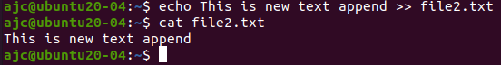

1. **head ‘filename’:** Prints the first starting 10 lines (default) onto the terminal.

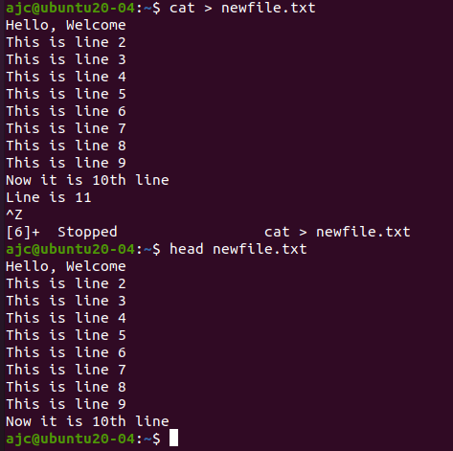

* 1. **head –‘n’ ‘filename’:** The prints the starting ‘n’ no. of lines onto the terminal.

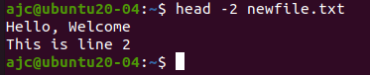

1. **tail ‘filename’:** Prints the first last 10 lines (default) onto the terminal.

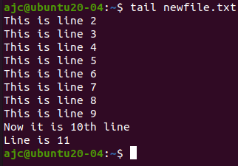

* 1. **tail -‘n’ ‘filename’:** The prints the last ‘n’ no. of lines onto the terminal.

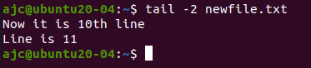

1. **cut -d’delimiter’ -‘f(n)’ ‘filename’:** This command is used to cut the specified portion of the mentioned file with the help of mentioned delimiter/character and also along with the specified column number ‘n’ that is formed after the splicing the contents into ‘m’ no. of columns of data using the delimiter and finally printing it to the terminal console.  
   **E.g., cut -d- -f2 std.txt**

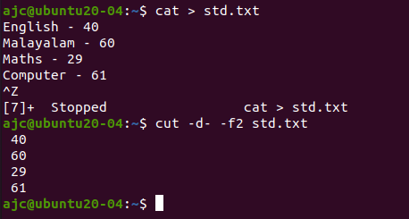

1. **rmdir ‘filename’:** Removes/Deletes the mentioned directory. (In order to delete, the mentioned directory should be an empty directory.)

$rmdir empty

